Population Risk Paper
Rachal Trigger
Ferris State University

Population Risk Paper
Individuals who have been convicted of a crime or those who pose a threat to others are incarcerated in jails or prisons. It is important to consider the health of this population because “illness and injury arrives at institutions with the inmates or detainees, occurs in these areas, and recycles back into neighborhoods when inmates and detainees leave” (Harkness & DeMarco, 2012, p. 343).
Risk Factors
This population is vulnerable for a couple of different reasons. Incarcerated individuals face “security issues; despairing attitudes; overcrowding; and the increased risk of communicable diseases such as tuberculosis, HIV infection, sexually transmitted infections (STIs), and hepatitis C; and fragmentation of families” (Harkness & DeMarco, 2012, p. 345).
Stereotypes and Bias
When looking at the population of correctional facilities, the amount of people of color is disproportionate to the population in general. Hispanics make up 16% of the U.S. population and 19% of the U.S. incarcerated population. Blacks make up 13% of the U.S. population and a shocking 40% of the U.S. incarcerated population. Non-Hispanic whites make up 64% of the U.S. population and only 39% of the U.S. incarcerated population (Prison Policy Initiative, 2014). Please see chart in appendix A.
The disproportionate numbers of people of color incarcerated leads one to wonder why this may have occurred. Racial profiling and immigration enforcement are two potential causes for these numbers. “Three out of every ten African American males born in the United States will serve time in prison, a status that renders their prospects for legitimate employment bleak and often bars them from obtaining professional licenses” (The Leadership Conference, 2015).
It is important for healthcare professionals to consider how the psychosocial health of prisoners is affected by incarceration. Individuals may have a difficult time finding affordable housing upon release. They may also have difficulty obtaining job training and meaningful work which may make financial independence impossible. Upon release from incarceration convicted felons even lose the right to vote and to carry a firearm.
Demographic and Population Data
Local
I reside in Pierce County in the state of Washington. The Pierce County Detention and Corrections Center is a medium/maximum custody facility with approximately 1300 inmates. The individuals incarcerated there have either been charged or convicted of a crime.
State
The state of Washington has 12 prisons with a combined population of about 16,488. 92.3% of the population is male and 7.7% is female. The average age is 37.7 years with an average length of stay of 23.3 months. The population is 71.5% white, 18.7% black, 12.1% Hispanic, 4.2% American Indian, 3.7% Asian, and 1.9% unknown.
National
It is estimated that 6,899,000 adult individuals are incarcerated in the United States (Bureau of Justice Statistics, 2015). This equates to approximately 2.8% of the population or 1 in 35 adults. 82% of the correctional population is male and 18% is female. The female inmate population is the fastest growing population of inmates which is growing an average of 3.4% yearly.

Health Concerns
Individuals who are incarcerated commonly face infectious diseases such as hepatitis, HIV/AIDS, MRSA, STDs, and tuberculosis. Inmates also struggle with chronic diseases such as arthritis, asthma, cancer, diabetes, heart disease, hypertension, and stroke. “Prisons serve as a concentration mechanism for relatively unhealthy individuals, partly because the behavioral and structural factors that lead to poor health (e. g., illicit drug use and alcoholism) are also associated with increased likelihood of incarceration” (Awofeso, 2010, p. 26).
Inmates who have been convicted of violent crimes have committed or been involved in unspeakable crimes. Despite these crimes, nurses must set aside bias and provide non-judgmental quality care. It is important to also remember that only a small portion of prisoners have been incarcerated for violent crimes. “75% of all prisoners are nonviolent” (Harkness & DeMarco, 2012, p. 345).
Hepatitis C is caused by a virus and transmitted from person to person through blood, drug equipment (needles), tattoos, piercing, scarring, and sexual activity. “Adults in correctional facilities are at risk for Hepatitis C because many people in jails or prisons already have Hepatitis C” (Centers for Disease Control and Prevention, 2013). In fact, 1 in 3 incarcerated individuals are infected with Hepatitis C (Centers for Disease Control and Prevention, 2013).
In 2007 a study done in Australia “revealed that 35% of 740 consecutive prison entrants were Hepatitis C virus-antibody positive” (Public Health Reports, 2010, p. 26). The sheer number of incarcerated individuals infected with Hepatitis C is cause for concern. One reason that may account for the high rate of Hepatitis C infection amongst prisoners is that “prisons amplify adverse health conditions through a culture that normalizes behaviors that are deleterious to health, such as tobacco use, injection drug use, an violence” (Public Health Reports, 2010, p.26-27).
Infection with the virus is a contributing factor to the high mortality rate from liver disease in the incarcerated population. Please see appendix B for data regarding mortality of inmates. Infection with the Hepatitis C virus is exacerbated by drug and alcohol use. This is an area where healthcare providers can provide education to prisoners. Inmates can be taught about the disease process and what can be done to slow or even in some cases clear the virus. Nurses can also teach prisoners ways to prevent Hepatitis C infection. It is important that prisoners understand how the virus is spread. Also they should be taught not to share “tattooing, piercing, or cutting equipment that has been used on someone else” (Centers for Disease Control and Prevention, 2013). Inmates should be taught about the importance of not sharing injection drug equipment such as needles, ties, water, etc. Finally, teaching needs to be provided on not sharing personal hygiene items such as razors and toothbrushes (Centers for Disease Control and Prevention, 2013).
Making a Difference
It is clear that incarcerated individuals are affected by chronic diseases as well as at great risk for infectious diseases. Correctional systems have struggled with providing adequate healthcare to their respective populations. “Part of the reason for lack of quality care relates to maintaining qualified and inspired healthcare personnel, the more formidable issue is public financing of the growing number of inmates’ healthcare needs” (Harkness & DeMarco, 2012, p. 346).
Nurses and healthcare professionals can help to alleviate the strain on the correctional healthcare system. Nurse who choose to work in the correctional setting have the potential to make a huge impact in their community. With the average inmate length of stay being 23.3 months the nurse would not only impact the jail/prison community but also the community at large. “Whatever improvements nurses engender concerning mental health, communicable disease, and physical wellness will eventually be a positive contribution to a family, a neighborhood, and a community” (Harkness & DeMarco, 2012, p. 346).
Healthcare professionals can work in the community to prevent re-incarceration. This can include mentoring at-risk children or volunteering individual talents or professional services to those in need.
A nurse doesn’t need to work in a jail or prison to improve the healthcare provided. Nurses can advocate for inmate healthcare by actively participating in nursing organizations and voting for legislature that supports and provides funding for the healthcare of those who are incarcerated.

References
Centers for Disease Control and Prevention. (2013). Hepatitis C and incarceration. Retrieved from http://www.cdc.gov/hepatitis/HCV/PDFs/HepCIncarcerationFactSheet-BW.pdf
Awofeso, N. (2010). Prisons as social determinants of hepatitis C virus and tuberculosis infections. Public Health Reports, 125(4), 25-27. Retrieved from http://www.publichealthreports.org/issueopen.cfm?articleID=2480
Harkness, G. A., & DeMarco, R. F. (2012). Community and public health nursing practice: Evidence for practice. Philadelphia, PA: Wolters Kluwer/Lippincott, Williams & Wilkins.
Prison Policy Initiative. (2014). Breaking down mass incarceration in the 2010 census: state-by-state incarceration rates by race/ethnicity. Retrieved from http://www.prisonpolicy.org/reports/rates.html
The Leadership Conference. (2015). Justice on trial. Retrieved from http://www.civilrights.org/publications/justice-on-trial/
U.S. Department of Justice. (2012). Mortality in local jails and state prisons, 2000-2010- statistical tables. Retrieved from http://www.bjs.gov/content/pub/pdf/mljsp0010st.pdf

Appendix A
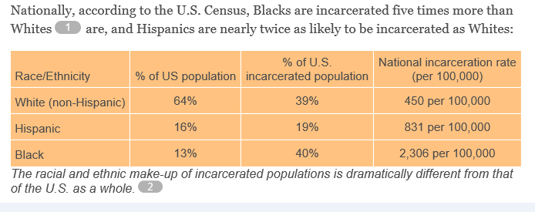
Note. Adapted from “Breaking Down Mass Incarceration in the 2010 Census: State-by-State Incarceration Rates by Race/Ethnicity,” by Prison Policy Initiative, 2014, Retrieved from http://www.prisonpolicy.org/reports/rates.html.

Appendix B
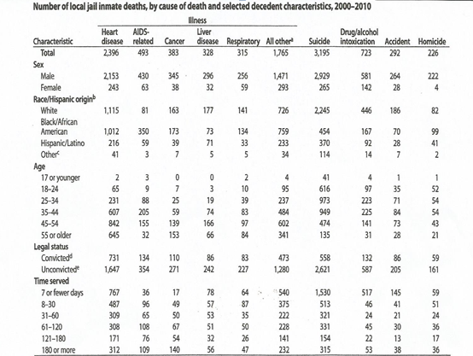

Note. Adapted from “Mortality in Local Jails and State Prisons, 2000-2010- Statistical Tables,” by U. S. Department of Justice, 2012, Retrieved from http://www.bjs.gov/content/pub/pdf/ mljsp 0010st.pdf.

